Q1. Python program to demonstrate various data types

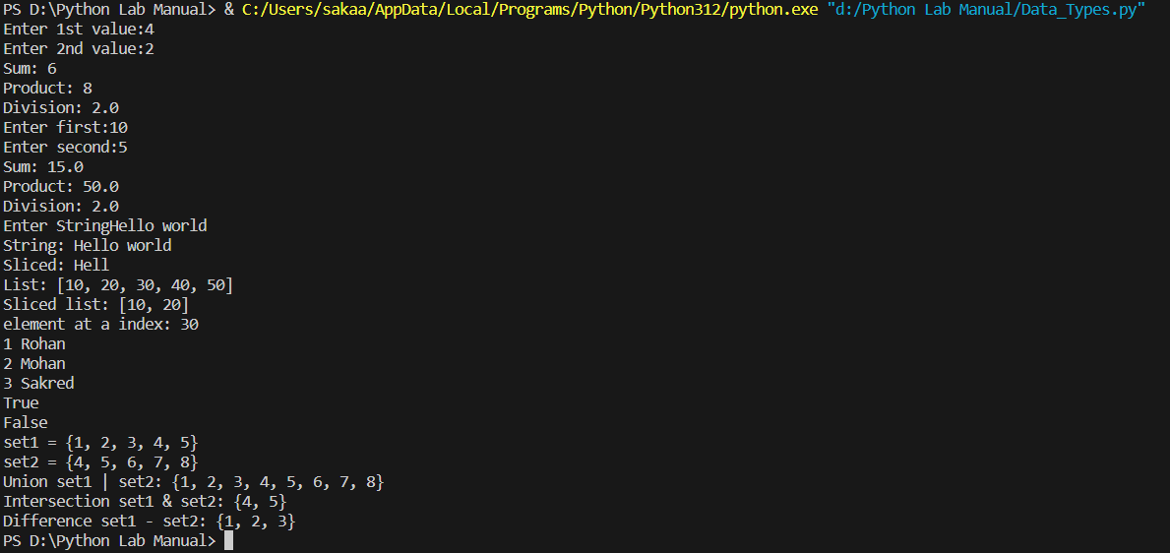

Q2Python program for working of various types of operators

Output:

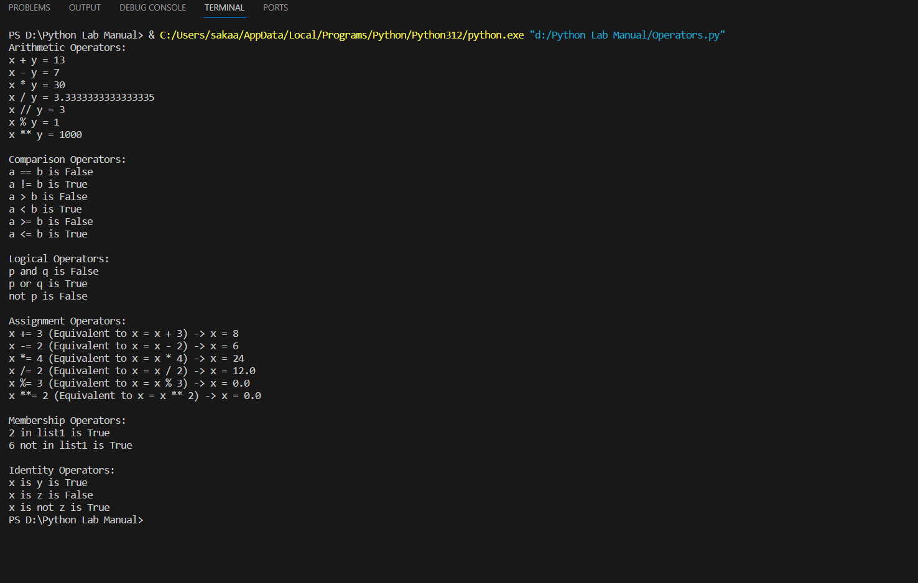

Q3: Write python code to demonstrate the condition and control flow statement

Code:

Output:

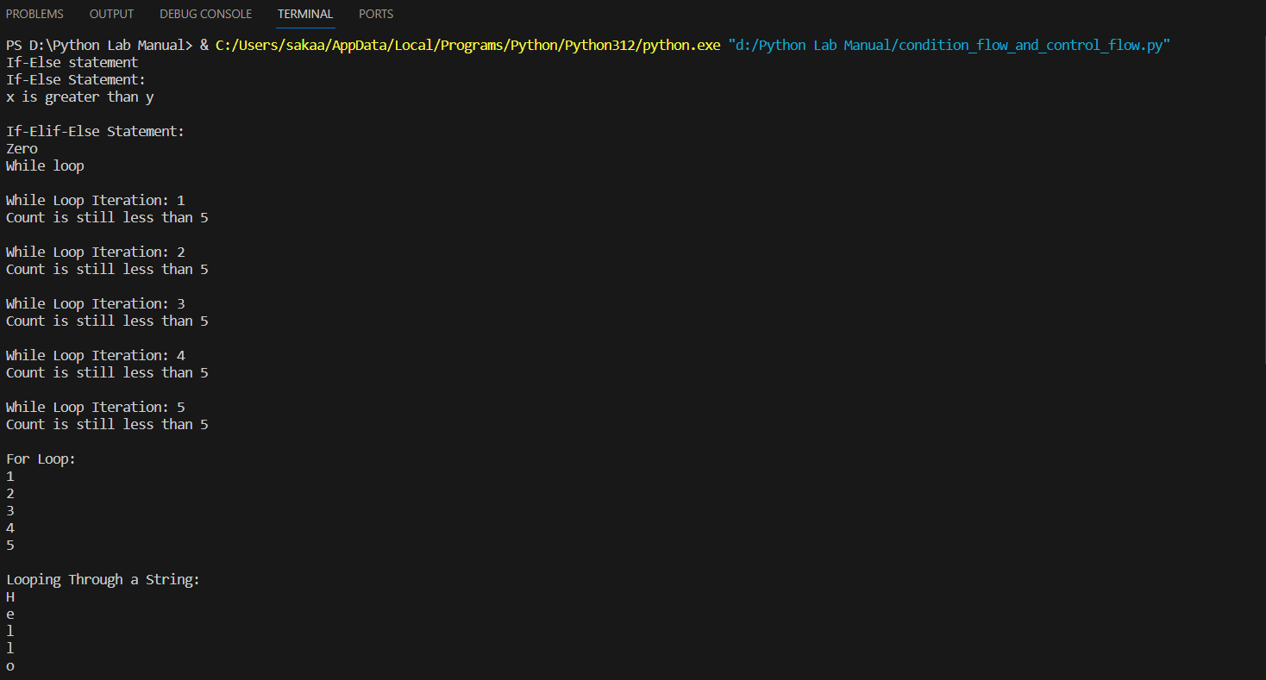

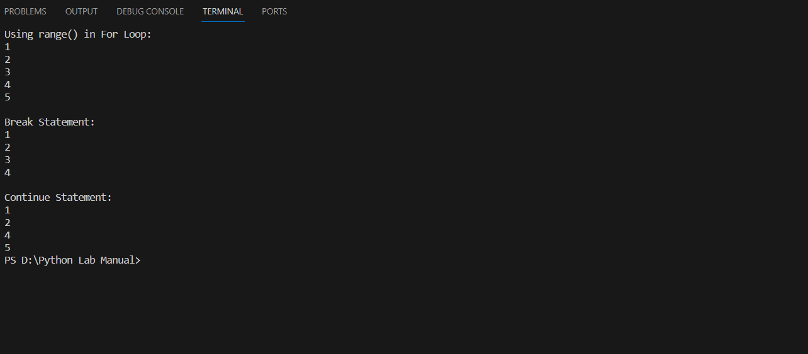

Pascal triangle

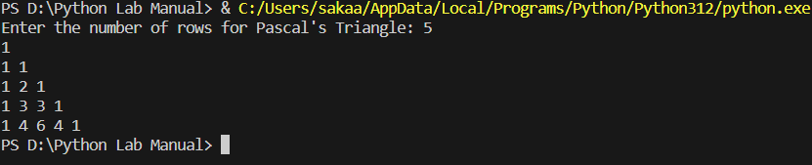

Panagram or not string

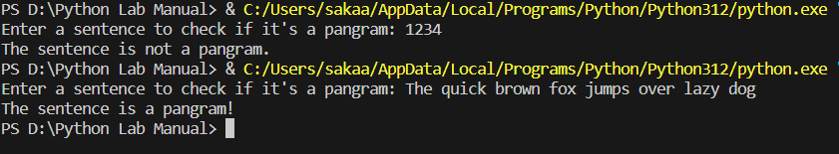Hyphen separated sequence

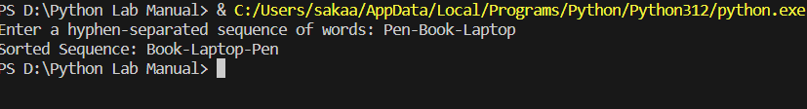

Function inside function

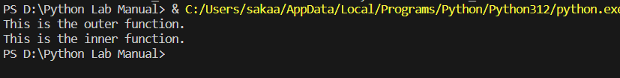

Local variables in function

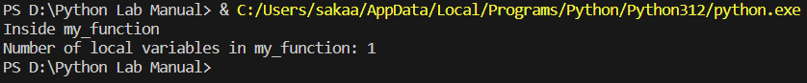

Invoked after 5 seconds



Pattern problems:

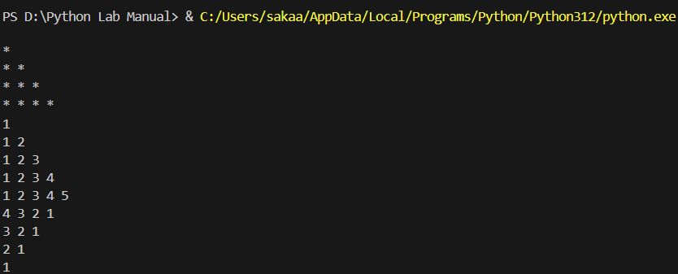

For_range

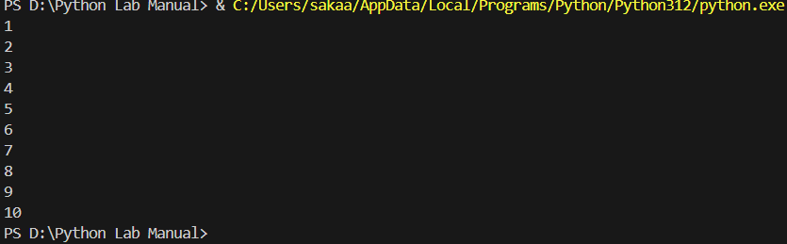

First N



Command line arguments



Hello_world



Matrix multiplication

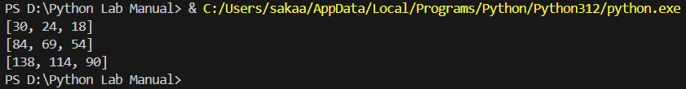

Factorial using recursion:

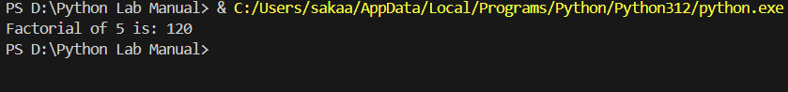

Exponential using recursion

